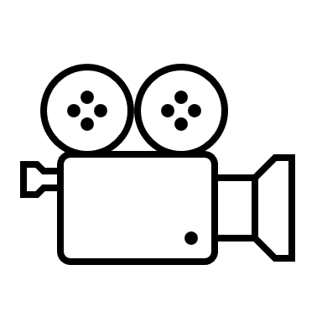

Capture Frame

Convert BGR to RGB

Process

Acquire required Landmarks

Draw Landmarks and Connections

Store captured landmarks in csv file

Import csv file as dataframe

Train-Test-split

(70:30)

Train ML Model

Make Predictions on test data using ML Model

Use ML Model to detect Action in live/video input